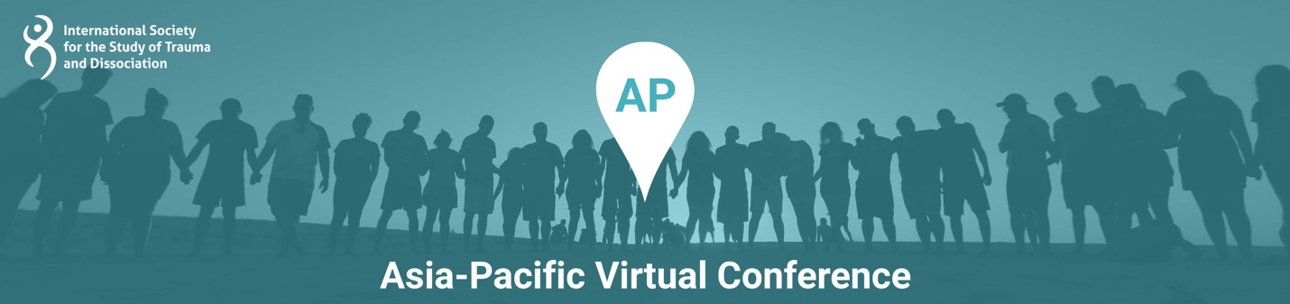

Presentation Title: APEX© – an Effective Model for Treating Non-Suicidal Self-Injury

Presentation Time: 90 minutes

Content Level: Beginning/ Introductory

Potential to Distress: No

Abstract: Drawing on evidence-based principles Diane Clare created the Alternatives to Self-Harm approach and designed the APEX© model that underpins this way of working with people who engage in non-suicidal self-injury. In this webinar she will outline the components of the APEX© model and how you might use them in practice. She compares the APEX model with treatment as usual and considers the core differences between APEX and DBT (Dialectical Behavior Therapy). The importance of Attitude in how we explore the purpose of self-harming is described. You will develop an understanding of why the Purpose(s) of the harming is important for achieving change. Diane will describe ways this model helps people match these purposes with strategies that meet their needs in less harmful ways. This is illustrated in the form of matched Emotional First Aid Kit ideas. The X factor of the model is a self-contract, which will be described, with examples. You will be invited to consider ways in which this model could enhance and support other approaches and therapies.

Learning Objectives:
At the conclusion of this presentation, participants will be able to:
- Describe the 4 core components of the APEX© model
- Begin to apply the APEX© model to practice
- Value how attitude is a key factor to assist with good outcomes
- Learn how matching the purpose of the harming to an alternative strategy is crucial to achieving a change in self-injurious behavior
- Justify why a self-contract is more likely to achieve change in the long-term

Presenter(s)

Diane Clare
Diane Clare is a registered clinical psychologist who trained at the University of Canterbury, New Zealand. Having worked in mental health and counselling services since 1981 first as a grief counsellor then as a psychotherapist with registration with NZ Association of Psychotherapists, she then registered as a psychologist in 1993. She has worked in a range of services in NZ and in the UK and provided leadership and Director level roles across a range of clinical services. This includes primary care, adult mental health, forensic, intellectual disability and tertiary student services. In the UK in 2005 she developed the Alternatives to Self-Harm program using the APEX model she has designed and since then, she has presented her work internationally as well as nationally in New Zealand. Outcome trends show demonstrated effectiveness for decreasing risk and increasing hope for those who engage in Non-Suicidal Self Injury. Now based on the Kãpiti Coast near Wellington, New Zealand, she is a seasoned presenter and provides a range of workshop training through GROW NZ Ltd. with an emphasis on practical solutions for clinical staff. She has a specialist interest in working with people with complex trauma and dissociation including Dissociative Identity Disorder. Diane is a registered Accredited EMDR Practitioner, and she was elected to the EMDR-NZ Board in 2020. She was the Chair of the organising Committee for the ISSTD Regional Conference in Otautahi Christchurch New Zealand 2019 receiving a President’s Award of Distinction for this work. She is part of the organising Committee for the ISSTD Regional Conference in Melbourne Australia in 2021 now delayed to 2022. Her webinar at the Asia Pacific Virtual Conference in 2021 is about her work with the APEX approach to NSSI.

