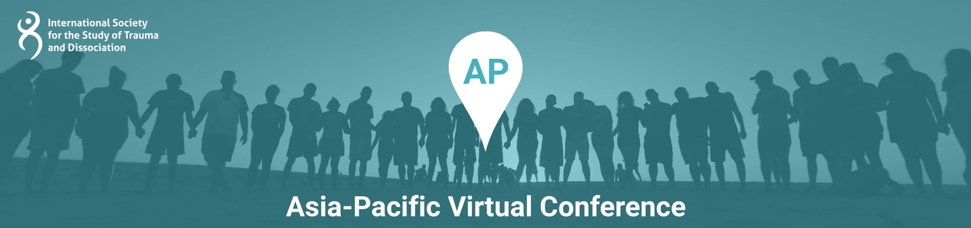

Presentation Title: Family Dynamics in Complex Trauma and Dissociation - a Case Series from India

Presentation Time: 90 Minutes

Content Level: Intermediate

Potential to Distress: Yes

Abstract: In the study of complex trauma and dissociation, family dynamics is an important contributor in the development and maintenance of symptoms. This case series describes the work with clients who present with complex trauma and dissociation within a relational context, perpetuated by family dynamics and historical trauma in Indian urban families. Indian culture in general promotes a hierarchical collectivistic society. The sense of identity is based in relation with others. Parenting styles in India lean toward authoritarian methods to discipline children. In the Indian context, historical and intergenerational trauma are important factors to consider as underpinnings for Adverse Childhood Experiences (ACEs), in the development of trauma-related conditions.
This case series outlines three cases with the common thread of family dynamics underlying the development of complex trauma and dissociation. The current presentation highlights the influence of attachment patterns, authoritarian parenting, lack of individuation, intergenerational transmission of trauma, marital discord, and nuclear and extended family structures in the etiology of complex trauma and dissociation. The interplay of Eastern and Western cultures while growing up in dysregulated family environments would be looked at. The cases will elaborate the client’s clinical presentation, treatment course and treatment gains presented by three professionals in private practice. Decision making in the processes of conceptualizations, adaptations in assessment and treatment protocols would be discussed. The presentation would also show the journey of therapists including the therapeutic alliance, therapist errors and client progress while learning to work with trauma and dissociation incorporating modern tools for treatment.

Learning Objectives:
At the conclusion of this presentation, participants will be able to:
- Label three features of Indian family dynamics that influence the development of complex trauma and dissociation
- Critically consider the significance of addressing family dynamics and repairing attachment bonds as a treatment goal using diverse treatment modalities
- List three challenges of adapting therapeutic interventions for trauma and dissociation specific to a cultural milieu

Presenter(s)

Adithy
Adithy is a counseling psychologist in Pune, India, involved in education, prevention, intervention and postvention work in the field of mental health for 20 years. She takes the approach of trauma healing in her psychotherapy. Her interest in trauma and dissociation has led her to creating collaborative learning environments for empowering professionals in working effectively in this area, in the form of study groups, interest groups, peer consultation groups, workshops, webinars, etc. She has been part of the training teams as practicum facilitator for EMDR therapy in Asia and as assistant for Integral Somatic Psychology in India. She has experience jointly training and leading teams that offer psychosocial support after disasters, including 2018 floods in Kerala. She has also jointly developed and implemented programs for suicide prevention and support for survivors of suicide loss and volunteered as trauma therapist for disabled soldiers. She was an invited panelist at ISSTD’s World Congress on Complex Trauma in New York City in 2019. She has co-authored articles in international journals of mental health.

Hvovi Bhagwagar
Hvovi Bhagwagar is a Psychologist and Psychotherapist and currently works as a private practitioner in her independent venture “Manashni” at Powai, Mumbai. She did her Masters in Clinical Psychology from SNDT University, Mumbai and is pursuing her Ph.D from Tata Inst of Social Sciences (TISS) on “Secondary traumatic Stress among Psychotherapists in India”. She is an International Affiliate with the APA (American Psychological Association) and an Associate of the IACP (Indian Assn of Clinical Psychologists). Her area of interest is in working with Traumatic stress and she has presented at National and International conferences and trained mental health professionals on Complex Trauma. During the COVID-19 Pandemic, she was part of several mental health initiatives including free counselling for Healthcare workers and grief affected families, organising a Support Group for Therapists and creating awareness through webinars. She has been Invited as a speaker at various Mental Health events and has received two awards - from the Young Environmentalists Foundation and Times Healthcare.

Karishma Shah Savla
Karishma Shah Savla is a psychotherapist in private practice from Mumbai, India. She has a Master’s in Counselling Psychology after doing a two-year certificate course in psychoanalytic observational studies based on the Tavistock model. She has worked as a school counsellor for a period of five years, working with children in groups & individual sessions, parents, teachers for classroom management & conducting parenting skills workshops.
Currently Karishma works with children, adolescents & adults in her private practice. She has been trained in EMDR & has been using it for the last ten years with mood disorders, anxiety disorders, traumatic stress disorders & dissociative disorders. She is a facilitator-in-training as well as a trainer-in-training with EMDR Asia. She is passionate about her work especially with children & traumatized individuals; she offers lectures, talks & consultation for students & emerging mental health professionals in the field of trauma and dissociation.

