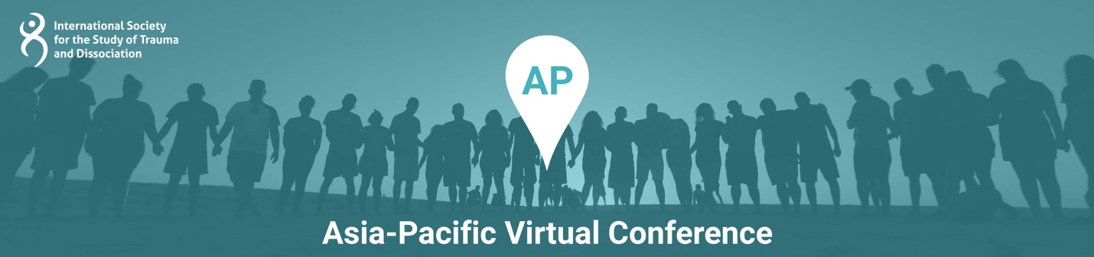

Presentation Title: Fit for purpose: Designing Systems and Recovery and Healing Services for Women with Lived Experience of Complex Trauma and Dissociation

Presentation Time: 90 Minutes

Content Level: Beginning/ Introductory

Potential to Distress: No

Abstract: It is well recognised that the psychosocial aftermath of child sexual abuse, domestic and family violence and sexual assault is poorly acknowledged and addressed across the service landscape, despite the efforts of specialist services and professionals. This presentation draws on national research into the service experiences of women with lived experience of complex trauma and dissociation, and the professionals who support them, to map out some of the key barriers to effective care and support for this group. We will present the preliminary findings of co-design work for the Women’s Trauma Recovery Centre, which aims to be a free and dedicated ‘one-stop wrap around service’ that addresses the complex health, legal and related needs of women recovering from domestic and family violence. We argue that women with experience of complex trauma not only have the right to recovery and wellbeing after abuse and violence, but that specialist, comprehensive, timely and freely accessible care is a ‘circuit breaker’ that interrupts the cycle of revictimization and intergenerational trauma.

Learning Objectives:
At the conclusion of this presentation, participants will be able to:
- Identify systemic and service barriers to recovery for women with traumatic and dissociative conditions
- Appraise the appropriateness of service models for complex trauma and their relationship with health and welfare system prerogatives
- Compare the benefits of comprehensive trauma care models with ‘siloed’ or single issue service approaches

Presenter(s)

Michael Salter, PHD
Dr Michael Salter is the Scientia Associate Professor of Criminology at the University of New South Wales. His research is focused on child sexual exploitation and technology-facilitated abuse. He is the author of two books, Organised Sexual Abuse (2013, Routledge) and Crime, Justice and Social Media (2017, Routledge), and over fifty papers on child abuse, violence and complex trauma. He is an expert advisor to the Australian eSafety Commissioner, White Ribbon Australia and the Canadian Centre for Child Protection. He sits on the Board of Directors of the International Society for the Study of Trauma and Dissociation, who awarded him the 2018 Morton Prince Award for Scientific Achievement and appointed him as a Fellow of the Society in 2021.

Sally Stevenson
Sally Stevenson AM is General Manager of the Illawarra Women’s Health Centre a position she has held for eight years. Sally has worked in public health for almost 30 years for organisations such as Médecins sans Frontiers, the World Health Organisation and the World Bank. She has been a member of the Independent Review Committee of the Global Alliance for Vaccines and Immunisation, the International Advisory Committee for Sexual Health and Family Planning Australia and the Human Research Ethics Committee of the University of Wollongong. She is Chief Investigator on two University of NSW projects: Transforming Domestic and Family Violence Response and Recovery Services, and Investigating Persistent Pain and Trauma. She is also the Principal Investigator on two joint University of Wollongong and Illawarra Women’s Health Centre research projects on domestic and family violence.

