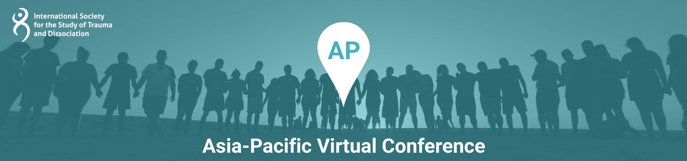

Presentation Title: Trauma and Dissociation in India, China and the Asian Pacific

Presentation Time: 90 minutes

Content Level: Intermediate

Potential to Distress: No

Abstract: In this workshop the presenters will review their research and clinical experience with dissociative disorders in China, Hong Kong, India and the Asian Pacific. This work has resulted in over 25 peer-reviewed papers. They will describe the prevalence of dissociative disorders in China, assessment tools they have used in their research, and a web-based psychoeducational program they have developed in Hong Kong. Also, they will discuss the potential role of social workers in providing services to individuals with dissociative disorders in the Chinese context and gaps in research, education and clinical services for dissociative disorders. In addition, they will describe the clinical presentation of DID and OSSD in Chinese cultures.

Learning Objectives:
At the conclusion of this presentation, participants will be able to:
- Describe a web-based psychoeducational program for dissociation developed in Hong Kong
- Explain research tools used in the Chinese context
- Identify gaps in research, education, and clinical services in the Chinese context

Presenter(s)

Colin A. Ross,MD
Dr. Ross is a Past President of the ISSTD and the author of 36 books and 250 peer-reviewed papers. He has spoken at conferences in China, Malaysia, Australia and New Zealand.

Hong Wang Fung
Andy H.W. Fung is a social worker and a researcher from Hong Kong. He is currently a PhD Candidate at The Hong Kong Polytechnic University. His research focuses on trauma, dissociation, mental health, and psychosocial care. He authored the psychoeducation book Be a Teammate with Yourself: Understanding Trauma and Dissociation (available in both English and Chinese) together with Colin A. Ross, M.D. His studies demonstrated that trauma and dissociation should not be ignored in the Chinese cultures and proposed that dissociation is a transdiagnostic indicator of psychosocial intervention needs. He is also the founder of the Hong Kong Association Concerning Dissociative Disorders (HKACDD).

